

**Kobe’s Item Shop System**

# **USERS MANUAL**

**Prepared by:**

Sean Daryle H. Marbella

BS Information Technology 3-B

**Submitted to:**

Dr. Michael Angelo D. Brogada

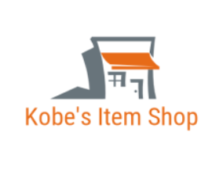

**TABLE OF CONTENTS**

## 1.INTRODUCTION……………………………………………………………………………………………………………………… 4

## 2. GETTING STARTED………………………………………………………………………………………………………………….5

## 3. DASHBOARD...............................................................................................................................6

## 4. ORDER TRACK………………………………………………………………………………………………………………………..7

4.1 Add

4.2 Update

4.3 Delete

4.4 Locate

4.5 Backup

4.6 Print

4.7 Dashboard

## 5. ORDER DETAILS TRACK…………………………………………………………………………………………………………8

5.1 Add

5.2 Update

5.3 Delete

5.4 Locate

5.5 Backup

5.6 Print

5.7 Dashboard

## 6. PRODUCTS TRACK ………………………………………………………………………………………………………………10

6.1 Add

6.2 Update

6.3 Delete

6.4 Locate

6.5 Backup

6.6 Print

6.7 Dashboard

## 7. CUSTOMERS TRACK……………………………………………………………………………………………………………12

7.1 Add

7.2 Update

7.3 Delete

7.4 Locate

7.5 Backup

7.6 Print

7.7 Dashboard

## 8. USERS TRACK……………………………………………………………………………………………………………………….14

8.1 Add

8.2 Update

8.3 Delete

8.4 Locate

8.5 Backup

8.6 Print

8.7 Dashboard

## INTRODUCTION

Welcome to the user manual for Kobe's Item Shop System, created exclusively for administrators like yourself. This manual will provide you with comprehensive guidance on the features and functions of our system, empowering you to efficiently handle order records, order details, product records, user processes, and customer lists.

As an administrator, your role is crucial in ensuring the smooth operation of your educational institution. Our Kobe's Item Shop System is specifically designed to simplify your tasks and offer you a seamless experience while overseeing various aspects of order management. Within this manual, you will find detailed instructions on navigating the user interface and utilizing the powerful tools available to you. We have strived to create an engaging and informative manual that will make your reading experience enjoyable while equipping you with the knowledge necessary to maximize our system's potential.

Kobe's Item Shop System provides a range of features that will streamline your administrative responsibilities. You will have the ability to effortlessly create and manage order profiles, ensuring accurate and up-to-date records. Furthermore, you can efficiently assign order details to products and monitor their schedules, facilitating effective organization of orders.

Customer management becomes hassle-free with our system, enabling you to easily handle customer profiles and their associated processes. You can view and manage customer lists, track available spaces, and generate reports on customer statistics. By automating these processes, you will save valuable time and resources.

The user list module allows you to create and manage users for different purposes. You can set deadlines, track submissions, and provide feedback, all from a centralized location. This feature promotes efficiency and transparency in the user management process, ensuring a smooth workflow for both administrators and users.

Throughout this manual, we will provide step-by-step instructions, tips, and best practices to help you optimize your use of Kobe's Item Shop System. We understand the significance of your role as an administrator and have developed our system to support you in achieving your objectives.

So, delve into the following pages and explore how Kobe's Item Shop System can revolutionize the way you manage order records, order details, product administration, customer processes, and user lists. We hope you find this manual informative and enjoy the process of discovering the capabilities of our system.

## 2. GETTING STARTED

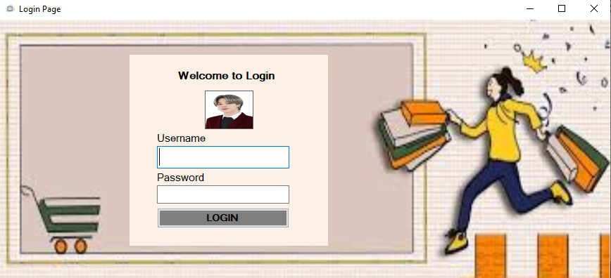

To begin using the Kobe’s Item Shop System, you will first need to access the login page. Follow the steps below to get started:

1. Open the Kobe’s Items Shop Application System
2. Enter your credentials the username and password.
3. Click on the "LOGIN” button to access the system.

## 3. DASHBOARD

Upon logging into our Kobe’s Item Shop System, you will see the dashboard, which serves as the central control for all your student administration needs. Think of it as a one-stop hub where you can access and manage various aspects of items shop system in a streamlined and efficient manner. The dashboard is designed to provide a comprehensive range of functionalities and features to meet your specific requirements. It acts as a command center, allowing you to efficiently manage and monitor all essential aspects of track module.

By centralizing all these functionalities in one place, the dashboard eliminates the need for multiple systems or manual processes, saving you time and effort. You can perform tasks quickly and effectively, reducing administrative burdens and allowing you to focus on more critical aspects of Kobe’s Item Shop System.

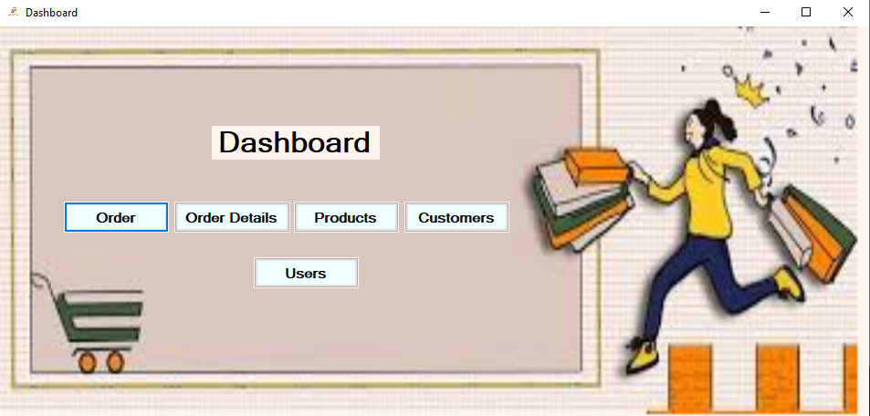

## 4. ORDERS TRACK

The Order Management page within our system offers a robust platform for efficiently handling and managing order information. It provides essential tools and functionalities to effectively track, organize, and engage with your order database, including access to a detailed list of customers with their Order ID, Customer ID, Order Date, Amount, and lastly is Price range.

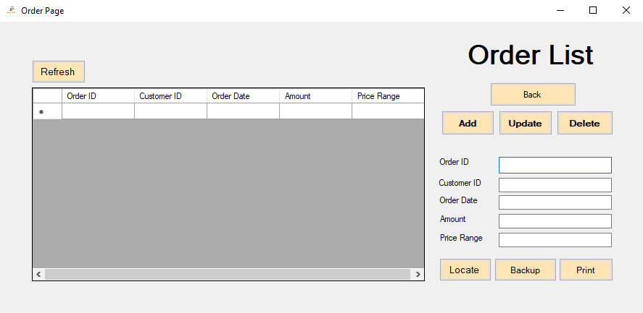

**4.7 Back**

**4.6 Print**

**4.5 Backup**

**4.4 Locate**

**4.3 Delete**

**4.2 Update**

**4.1 Add**

**4.1** **Add**

The functionality provides a convenient way to incorporate new orders into your database.

### 4.2 Update

The "Update" button allows you to modify and update student information effortlessly. By clicking on the "Update" button, you gain access to an intuitive interface where you can make changes to various details.

### 4.3 Delete

The "Delete" button allows you to delete student records by inputting their unique identification details. And you can easily delete their record from the database.

### 4.4 Locate

The "Locate" button allows you to easily navigate to your files and select a specific file for viewing within the datagrid. By clicking on the "Locate" button, a file browser window will open, allowing you to browse through your files and select the desired file. Once the file is selected, its contents will be displayed in the datagrid.

### 4.5 Backup

The "Backup" button allows you to create a secure backup of the data stored within the datagrid. By selecting the "Backup" button the system initiates a process to save a copy of the data to a designated backup location.

### 4.6 Print

The "Print" button allows you to generate an Excel file using a student template provided. Upon clicking the "Print" button, the system dynamically generates an Excel file that includes order data and information.

### 4.7 Back

The "Back" button is conveniently positioned in the top right corner of the interface, providing easy access to the main dashboard of the student management system. By clicking on the "Back" button, you are instantly redirected to the central hub of the system.

## 5. ORDER DETAILS TRACK

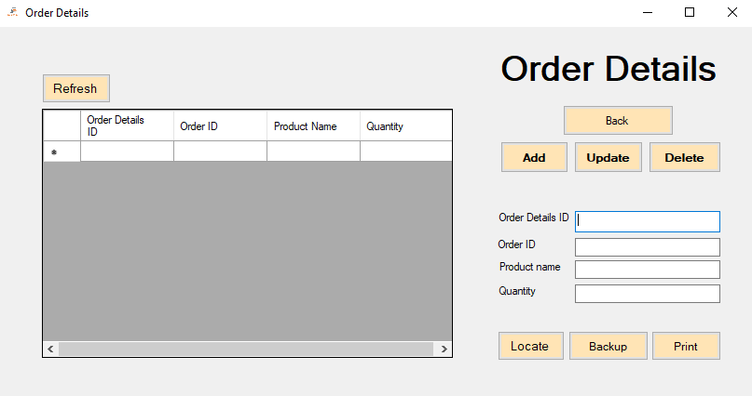The Order Details Management page within our system offers a comprehensive platform for efficiently handling and managing Order Details information. It provides essential tools and functionalities to effectively track, organize, and engage with your teacher database. Order Details Management page simplifies the management of order details informatseamless tracking, organization, and engagement with your order detail database.

**5.4 Locate**

**5.5 Backup**

**5.6 Print**

**5.7 Back**

**5.3 Delete**

**5.2 Update**

**5.1 Add**

**5.1** **Add**

The functionality provides a convenient way to incorporate new order detail into your database. Through a user-friendly input form, you can effortlessly input important information.

### 5.2 Update

The "Update" button allows you to modify and update order detail information effortlessly. By clicking on the "Update" button, you gain access to an intuitive interface where you can make changes to various orders details.

### 5.3 Delete

The "Delete" button allows you to delete order detail records. By entering the Delete button, you can easily delete their record from the database.

### 5.4 Locate

The "Locate" button allows you to easily navigate to your teacher files and select a specific file for viewing within the datagrid. By clicking on the "Locate" button, a file browser window will open, allowing you to browse through your files and select the desired file. Once the file is selected, its contents will be displayed in the datagrid, presenting the order detail information in a structured format.

### 5.5 Backup

The "Backup" button allows you to create a secure backup of the data stored within the datagrid. By selecting the "Backup" button the system initiates a process to save a copy of the data to a designated backup location. This ensures that the order detail records and related information are safely preserved in case of any unforeseen events or dataloss.

**5.6 Print**

The "Print" allows you to generate an Excel file using a teacher template provided. Upon clicking the "Print" button, the system dynamically generates an Excel file that includes teacher data and information. Each time you initiate the print function, the system automatically incorporates the current time and date into the file name, enabling easy identification and tracking of the saved files.

### 5.7 Back

The "Back" button is conveniently positioned in the top right corner of the interface, providing easy access to the main dashboard of the order detail management system. By clicking on the "Back" button, you are instantly redirected to the central hub of the system, where you can view a comprehensive overview of the system.

## 6. PRODUCT TRACK

The Product Details Management page within our system offers a comprehensive platform for efficiently handling and managing Product Details information. It provides essential tools and functionalities to effectively track, organize, and engage with your product database. Product Details Management page simplifies the management of product details information, enabling seamless tracking, organization, and engagement with your product detail database.

**6.7 Back**

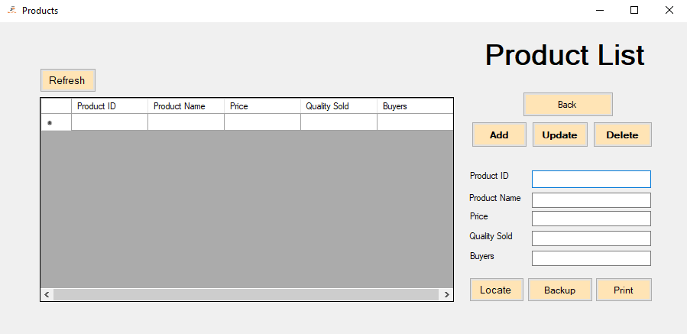

**6.2 Update**

**6.1 Add**

**6.3 Delete**

**6.4 Locate**

**6.5 Backup**

**6.6 Print**

**6.1 Add**

The functionality provides a convenient way to incorporate new products into your database. Through a user-friendly input form, you can effortlessly input important information.

**6.2 Update**

The "Update" button allows you to modify and update product detail information effortlessly. By clicking on the "Update" button, you gain access to an intuitive interface where you can make changes to various product details.

**6.3 Delete**

The "Delete" button allows you to delete product detail records. By entering the Delete button, you can easily remove their record from the database.

**6.4 Locate**

The "Locate" button allows you to easily navigate to your product files and select a specific file for viewing within the datagrid. By clicking on the "Locate" button, a file browser window will open, allowing you to browse through your files and select the desired file. Once the file is selected, its contents will be displayed in the datagrid, presenting the product detail information in a structured format.

**6.5 Backup**

The "Backup" button allows you to create a secure backup of the data stored within the datagrid. By selecting the "Backup" button, the system initiates a process to save a copy of the data to a designated backup location. This ensures that the product detail records and related information are safely preserved in case of any unforeseen events or data loss.

**6.6 Print**

The "Print" allows you to generate an Excel file using a product template provided. Upon clicking the "Print" button, the system dynamically generates an Excel file that includes product data and information. Each time you initiate the print function, the system automatically incorporates the current time and date into the file name, enabling easy identification and tracking of the saved files.

**6.7 Back**

The "Back" button is conveniently positioned in the top right corner of the interface, providing easy access to the main dashboard of the product detail management system. By clicking on the "Back" button, you are instantly redirected to the central hub of the system, where you can view a comprehensive overview of the system.

## 7. CUSTOMERS TRACK

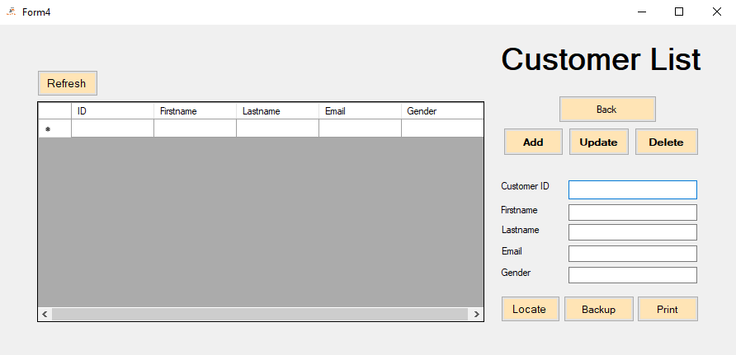The Customers Track Management page within our system offers a comprehensive platform for efficiently handling and managing customer information. It provides essential tools and functionalities to effectively track, organize, and engage with your customer database. Customers Track Management page simplifies the management of customer details, enabling seamless tracking, organization, and engagement with your customer database.

**7.1 Add**

**7.7 Back**

**7.6 Print**

**7.5 Backup**

**7.4 Locate**

**7.3 Delete**

**7.2 Update**

**7.1 Add**

The functionality provides a convenient way to incorporate new customers into your database. Through a user-friendly input form, you can effortlessly input important information.

**7.2 Update**

The "Update" button allows you to modify and update customer information effortlessly. By clicking on the "Update" button, you gain access to an intuitive interface where you can make changes to various customer details.

**7.3 Delete**

The "Delete" button allows you to remove customer records. By clicking on the Delete button, you can easily delete their record from the database.

**7.4 Locate**

The "Locate" button allows you to easily navigate to your customer files and select a specific file for viewing within the datagrid. By clicking on the "Locate" button, a file browser window will open, allowing you to browse through your files and select the desired file. Once the file is selected, its contents will be displayed in the datagrid, presenting the customer information in a structured format.

**7.5 Backup**

The "Backup" button allows you to create a secure backup of the data stored within the datagrid. By selecting the "Backup" button, the system initiates a process to save a copy of the data to a designated backup location. This ensures that the customer records and related information are safely preserved in case of any unforeseen events or data loss.

**7.6 Print**

The "Print" allows you to generate an Excel file using a customer template provided. Upon clicking the "Print" button, the system dynamically generates an Excel file that includes customer data and information. Each time you initiate the print function, the system automatically incorporates the current time and date into the file name, enabling easy identification and tracking of the saved files.

**7.7 Back**

The "Back" button is conveniently positioned in the top right corner of the interface, providing easy access to the main dashboard of the customer management system. By clicking on the "Back" button, you are instantly redirected to the central hub of the system, where you can view a comprehensive overview of the system.

**8. USERS TRACK**

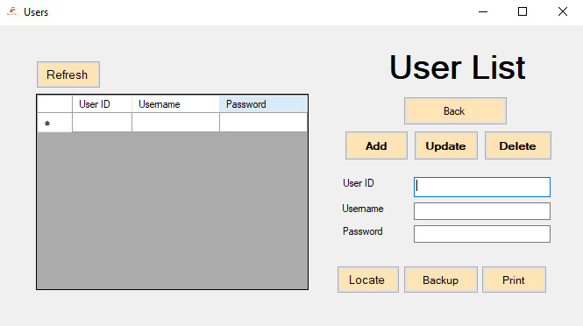The Users Track Management page within our system offers a comprehensive platform for efficiently handling and managing user information. It provides essential tools and functionalities to effectively track, organize, and engage with your user database. Users Track Management page simplifies the management of user details, enabling seamless tracking, organization, and engagement with your user database.

**8.1 Add**

**8.3 Delete**

**8.2 Update**

**8.7 Back**

**8.6 Print**

**8.5 Backup**

**8.4 Locate**

**8.1 Add**

The functionality provides a convenient way to incorporate new users into your database. Through a user-friendly input form, you can effortlessly input important information.

**8.2 Update**

The "Update" button allows you to modify and update user information effortlessly. By clicking on the "Update" button, you gain access to an intuitive interface where you can make changes to various user details.

**8.3 Delete**

The "Delete" button allows you to remove user records. By clicking on the Delete button, you can easily delete their record from the database.

**8.4 Locate**

The "Locate" button allows you to easily navigate to your user files and select a specific file for viewing within the datagrid. By clicking on the "Locate" button, a file browser window will open, allowing you to browse through your files and select the desired file. Once the file is selected, its contents will be displayed in the datagrid, presenting the user information in a structured format.

**8.5 Backup**

The "Backup" button allows you to create a secure backup of the data stored within the datagrid. By selecting the "Backup" button, the system initiates a process to save a copy of the data to a designated backup location. This ensures that the user records and related information are safely preserved in case of any unforeseen events or data loss.

**8.6 Print**

The "Print" allows you to generate an Excel file using a user template provided. Upon clicking the "Print" button, the system dynamically generates an Excel file that includes user data and information. Each time you initiate the print function, the system automatically incorporates the current time and date into the file name, enabling easy identification and tracking of the saved files.

**8.7 Back**

The "Back" button is conveniently positioned in the top right corner of the interface, providing easy access to the main dashboard of the user management system. By clicking on the "Back" button, you are instantly redirected to the central hub of the system, where you can view a comprehensive overview of the system.